Learner #1: Kira Miller
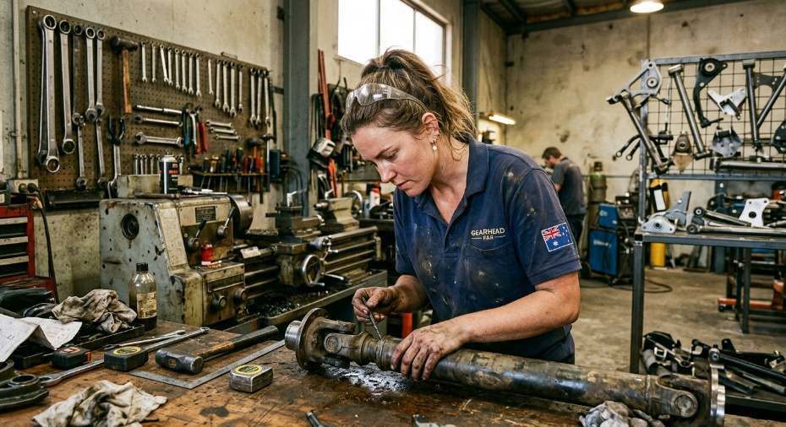
About Me: | Kira is a 28-year-old workshop owner based in Gawler, South Australia, where she runs Miller Custom 4x4, a small specialist business focused on driveline fabrication and heavy-duty suspension work for lifted four-wheel-drives. She is well known across SA's off-road community, particularly through her signature “Miller Mod” tail-shaft conversion, which has been featured in Off-Road Action magazine and discussed widely on enthusiast forums.  Outside the workshop, Kira lives on a semi-rural block on the northern outskirts of Gawler, where her home internet is patchy and tends to drop out during peak times. She is currently juggling business ownership with her own studies and is enrolled in further training to formalise the teaching she already does informally on the shop floor.
Professional and Learning Experience: | Kira completed her AUR30620 Certificate III in Light Vehicle Mechanical Technology in 2020, finishing her apprenticeship at Gawler Service Centre with above-average assessment results and a particular strength in drivetrain and suspension diagnostics. Since founding Miller Custom 4x4 in 2021, she has built a substantial body of practical experience in precision machining (manual lathe work, thread cutting, custom shaft turning to 0.01mm tolerances), TIG and MIG welding, and complex driveline geometry calculations.  She holds a current SA Licensed Vehicle Inspector ticket and was named Young Mechanic of the Year (Regional SA) in 2022. Kira is presently working through her TAE40122 Certificate IV in Training and Assessment, with her practicum based in an automotive workshop. She also has informal coaching experience: guest-presenting at the AusFab Regional Expo, running club workshop days, mentoring two junior fabricators into lead-tech roles, and producing a YouTube channel of technical build videos averaging 8,000 views per upload.
Career/Training Goals: | Kira's longer-term goal is to move into formal training delivery within the automotive trades, where she sees a clear gap in advanced fabrication and driveline diagnostics content. She wants to bring her hands-on, “real-world physics” approach into the classroom and workshop and eventually deliver units within the AUR and MEM training packages. The Cert IV in TAE is the immediate stepping stone, and she is open to further qualifications down the track if they help her cement her credibility as a trainer and assessor.
Working Style and Preferences: | Kira is overwhelmingly a hands-on, visual learner and teacher. Her own coaching method on the shop floor follows a “Tell, Show, Do” pattern: she will sketch driveline angles on a whiteboard, demonstrate the adjustment on the lathe, then watch the apprentice attempt it themselves. Her YouTube content reflects the same instinct, leaning on time-lapse footage and live demonstration rather than written explanation. She is highly numerate when the maths is applied (compound angles, gear ratios, run-out tolerances to thousandths of an inch), but tends to work problems out on a whiteboard or scrap paper rather than producing formal written documentation.  A recurring theme in employer and customer feedback is that Kira is more comfortable with the physics of the metal than with paperwork. A previous employer noted she sometimes deviates from manufacturer service bulletins in favour of her own engineered solutions, and a fleet customer raised concerns when she was unable to produce a Certificate of Compliance for work performed. Kira's own statutory declaration confirms this preference for “real-world” deviation over documented factory specifications.  Day-to-day, Kira's schedule is dictated by her workshop. She works long and irregular hours, often early starts, late finishes, and weekend jobs to keep customer vehicles moving, which means dedicated study time tends to fall into late evenings. She has her own laptop set up in a small home office for admin and study, but her fixed-wireless internet connection struggles with video streaming and large file downloads, particularly in the evenings when the local network is congested. On the workshop floor she defaults to her phone for quick reference material.
Additional Information: | Kira is active in the South Australian 4WD club scene and regularly attends weekend club events at Mount Crawford and the Flinders. She also takes on remote paid video consultations for interstate customers, which can occasionally clash with scheduled study commitments.  Two of her closest mentors are tradespeople she met through these networks rather than through formal training, and she strongly values learning that has obvious, demonstrable application to the work she does each day. She has mentioned in passing that any long stretches of reading or written assessment “aren't really her thing” and that she works best when a task gives her something to build, draw, or pull apart.

